[Date]

Simon Light

UTC Reading

Assignment 3

Unit 17

Contents

P6 - Follow a project plan to carry out a defined project 2

Workshop 1 2

Workshop 2 2

Workshop 3 3

Workshop 4 3

Final Day 4

M3 – Monitor the project against the project plan, adapting the plan as circumstances change 4

D1 - Demonstrate effective communications with stakeholders at all stages of the project 6

# P6 - Follow a project plan to carry out a defined project

Below is an initial project plan

## Workshop 1

In workshop 1 we were tasked with installing the necessary software onto our and the teams computers. Below is evidence of auto cad on a design team’s computer that we installed.

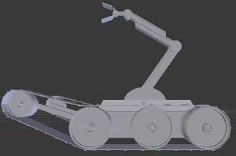

## Workshop 2

In workshop 2 we were tasked with starting software development and creating wireless links. Below is a picture of the raspberry pi running over our wireless link also running our code.

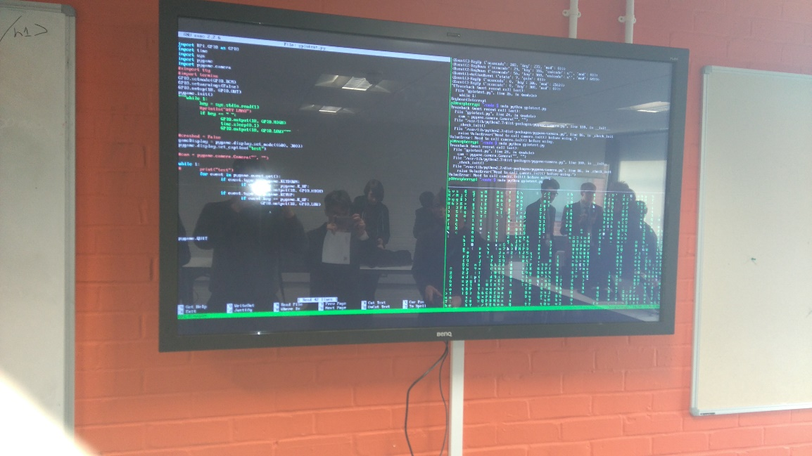

## Workshop 3

In workshop 3 we were tasked with submitting the final buy list. Below is a picture of the vex robot we used to help decide what parts we needed to order.

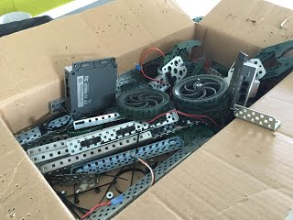

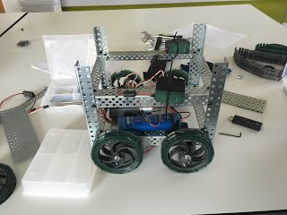

## Workshop 4

In workshop 4 we had to create the arm and 3d print it. Below is an image of the scale strut for the arm. This is proof that we were designing the arm.

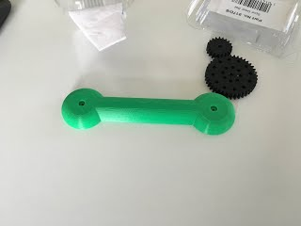

## Final Day

On the final day we had to finish all of the work and also create a presentation. Below is an image of the table we set up for the presentation day with the people who were presenting.

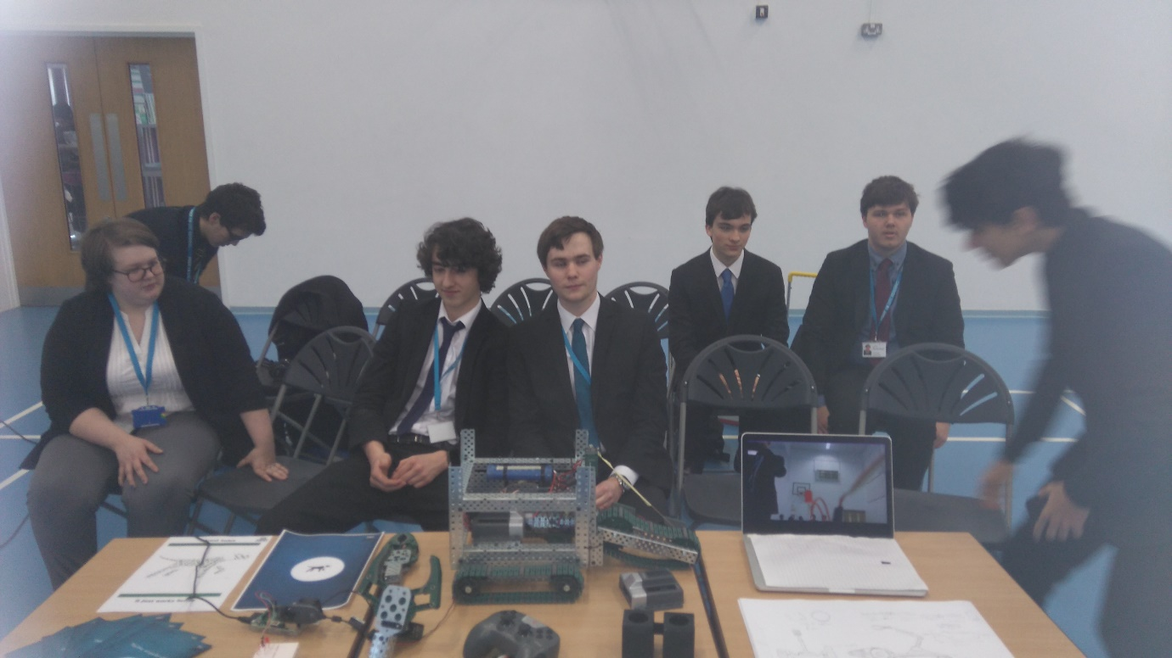

# M3 – Monitor the project against the project plan, adapting the plan as circumstances change

Below is the initial project plan

|  |  |  |
| --- | --- | --- |
| Date of issue | Issue | Outcome |
| Session 1 (8/1/16) | Competencies were un balanced | Got some people to change competencies until we felt that they were correctly weighted |
| Session 1 (8/1/16) | Competencies were unsure about planning | Team leaders were selected to guide |
| Session 2 (26/1/16) | Order sites and products were limited | Adapt plan around websites stock |
| Session 2 (26/1/16) | Design stage was way too ambitious | Find a way to deal with it or do less |
| Session 2 (26/1/16) | Parts were found to be unavailable | Find similar parts or adapt plan again |
| Session 3 (1/2/16) | After working with similar parts the ones chosen aren’t suitable | Re order different parts |
| Session 3 (1/2/16) | Parts list is needed and IT team isn’t sure what motors Design team are using | Ask ordering team to buy a control board suitable for the motors chosen |
| Session 4 (4/3/16) | No control boards for the motors were ordered | Buy some transistors from the college and start soldering one |
| Session 4 (4/3/16) | Raspberry pi wasn’t able to connect to college Wi-Fi | Use a mobile hotspot from phone |
| Session 4 (4/3/16) | Building of robot was underestimated | Finish the build in free time and next project time |
| Session 5 (18/3/16) | Neither the pi or the RCV were ready to combine | Test when both are ready |
| Session 5 (18/3/16) | Testing both electronics and robot together was not effective | Build a standalone robot movement system to allow testing to be done without IT |
| Session 5 (18/3/16) | Quite a few students weren’t on task | Assign them work to do and keep checking on them |
| Session 5 (18/3/16) | It was seen that the presentation team would need more time to rehearse | Bring the presentation preparation forward by a week |
| Session 6 (21/3/16) | The robot wasn’t ready to display | Do what we could to get it into an order to show |
| Session 6 (21/3/16) | 3D printer misprinted the arm | Just show proof of concept of the arm |
| Session 6 (21/3/16) | Some group members dropped out of the display team | Bring more people in |
| Session 6 (21/3/16) | The announcement will be done on (23/3/16) | Wait until that point |

Below is a table of all of the issues that were encountered during the project and how they were resolved.

Below is a project plan of what actually happened with all of the issues’ effects on the timeline.

# D1 - Demonstrate effective communications with stakeholders at all stages of the project

Below are a series of witness statements. These detail what I personally contributed to the project. There is also a signature and date to prove that the stakeholder approves that the work I did is legitimate. This shows direct communication with the stakeholder